## Soft PLC

### General

A PLC (programmable logic controller) is an electronic device with a microprocessor that, on the basis of its various inputs, controls its outputs. A good example is the Wago PLC that we use often with our system. To make it easier to use and also to extend the range to use it with, we developed a soft PLC for NavVision . It is way beyond the scope of this manual to explain in depth the various ways to use this soft PLC, so we merely touch the handling features. For more information please refer to Free Technics and in the future to the Soft PLC Manual.

#### Basics

When you open Soft PLC for the first time you get an empty screen (see Figure 2‑39)

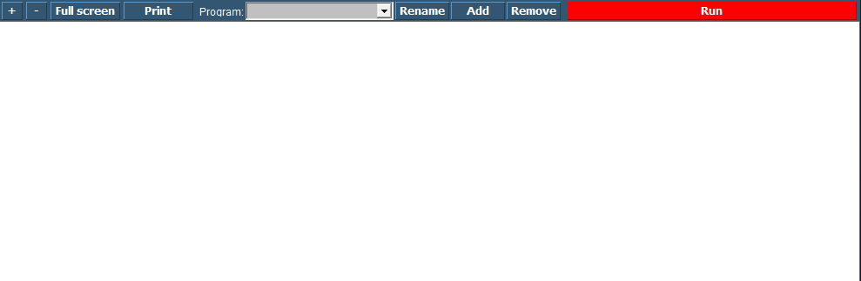

Figure 2‑39: Soft PLC

The following figures apply to the buttons on the screen:

|  |  |
| --- | --- |
| **Soft PLC Switch** | **Function** |
| +/- | Zoom in or out |
| Full Screen | Goto Fullscreen mode |
| Print | Print the Ladder Diagram |
| Program | Choose which PLC program you want to adjust by clicking the dropdown button |
| Rename | Rename the PLC program |
| Add | Add a new PLC program |
| Remove | Remove a PLC program |
| Run | Manually run or stop a specific PLC program |

### Simple example

Just to explain how it works, we will show a small example. This is merely to show how the diverse methods of implementing work in case you are already familiar with PLC programming.

#### Start

When you click “Add” you will start a new program. This program starts with an empty line an is called “SoftPLC1” if it is the first program you start. If you click “Rename” you can give it a distinctive name, which will pay off when you have a lot of PLC programs in your system (see Figure 2‑40).

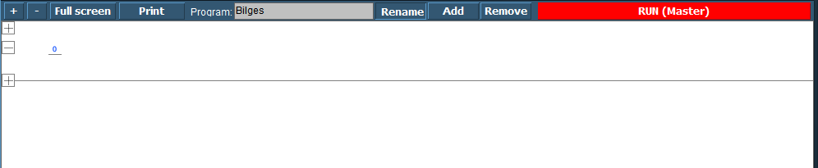

Figure 2‑40: SoftPLC Rename

Once you renamed it, you can go on with the program. For those familiar with PLC programming, you will recognize this as a ladder diagram. With the “+” you can add lines before or after and with “–“ you can remove the line.

We start this program with a bilge pump, which should run when a certain bilge alarm is high. When you click at the left side of the “0” a new pop-up appear with choices (see Figure 2‑41). These are beyond the scope of this manual to discuss, but if you know PLC programming, you will know what they are.

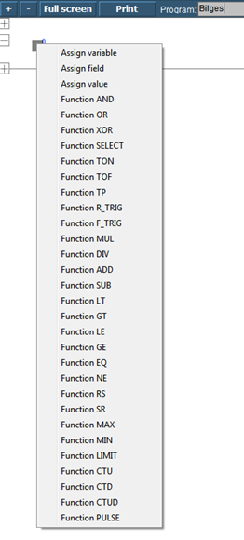

Figure 2‑41: SoftPLC pop-up

We choose for “Assign Field” to assign the Bilge Alarm as a trigger (see Figure 2‑42). Now we get into the FT part of the SoftPLC and we can work with this as we saw earlier in Chapter **Error! Reference source not found.**. After choosing this field the PLC line will look as in Figure 2‑43

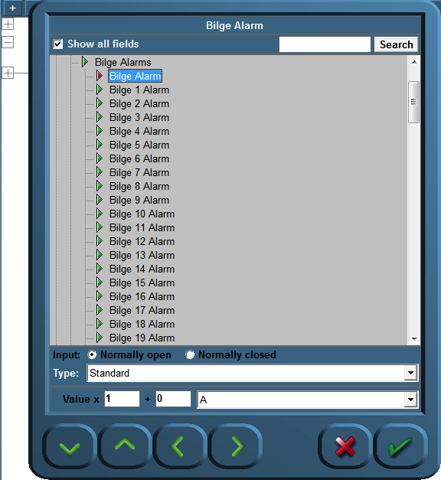

Figure 2‑42: SoftPLC Assign Field

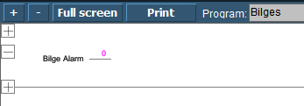

Figure 2‑43: SoftPLC first Line

We do the same at the right side of the “0” but this time we choose the Bilge Pump. We end up with a line like in Figure 2‑44.

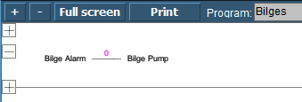

Figure 2‑44: SoftPLC First Line_2

So now when you press “Run” the program wll run and check the bilge alarm over and over. Once it gets high, the connection in the line gets high (1) and the Bilge Pump starts running until the alarm is not high anymore.

#### Control

You can understand that you can control the NavVision installation much more once you use SoftPLC. You can make all kind of interactive switches and much more. If you want to know more about it, please contact Free Technics.